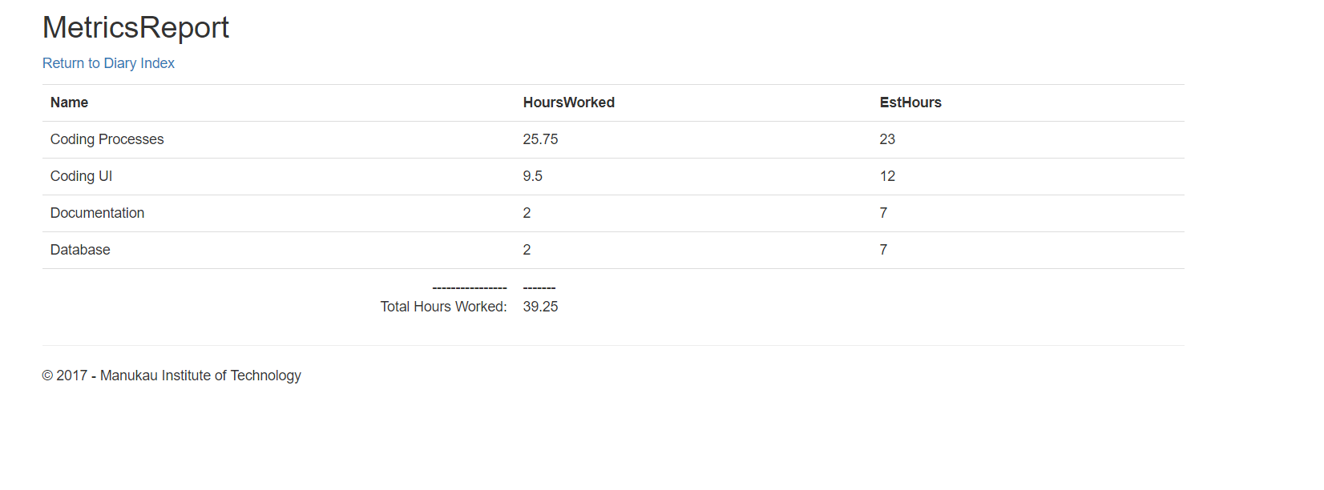

Most of my time went into doing coding processes and UI. This is because I spent a lot of time trying different ways to make paging work, but nothing was working for so long. I thought it would be good to get a table that would be able to update automatically even when new data was inserted. I spent way to much time on this and should’ve just used the simple way which was jQuery but I tried with other methods and they just did not work. I think my work really suffered from spending so much time on it because I was barely able to do anything with PayPal besides letting people pay with it. Kind of disappointed with what I have done.